OLYMPIA SCOPE 2024
SCOPE/OLYMPIA is an international exchange program that brings together Canadian and American Scouts and Scouters for an extended weekend of fun program and fellowship. This experience began in 1967 and has continued with the Canadian Scouts coming to the US and Scouts from the Cradle of Liberty Council going to Canada for the past 56 years. More information, fee schedule and registration are available at www.colbsa.org/scope.

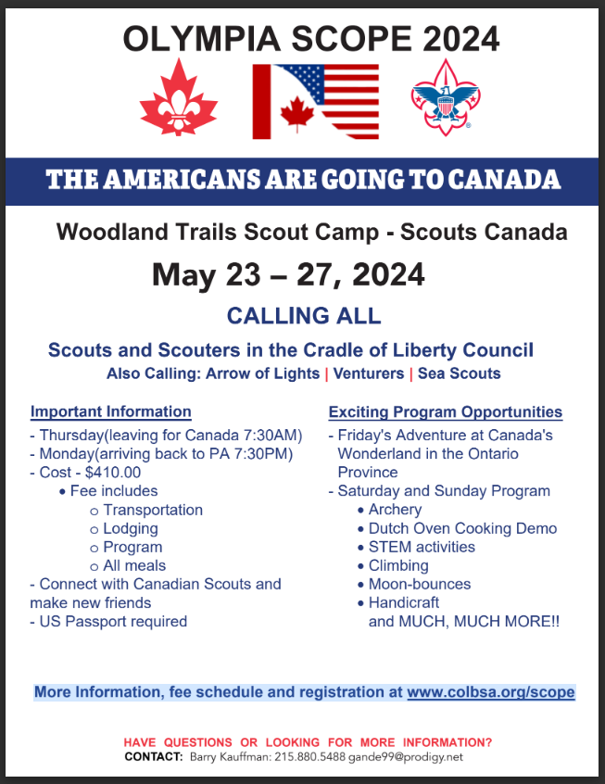

YOUTH LEADER TRAINING OPPORTUNITIES

National Youth Leader Training – NYLT

National Youth Leadership Training is an exciting, action-packed program designed to provide scouts with leadership skills and experience they can use in their home troops and in other situations demanding leadership of self and others. National Youth Leadership Training incorporates the latest leadership ideas and presents fresh, vital and meaningful training for today’s Scouts. The key elements are then taught with a clear focus on HOW TO. The skills come alive during the week as the patrol goes on a Quest for the Meaning of Leadership.

In order to attend NYLT, a youth must have the following qualifications by the start of the course:
- Must be a registered member of a Scouting unit.
- Must have a current BSA Health and Medical Record form parts A, B, and C.
- Scouts BSA members must be at least 13. They must have completed Introduction to Leadership Skills for Troops (ILSC) and earned First Class rank before attending NYLT.
- It is recommended that they have had at least one year of camping experience. While NYLT is not an outdoor skills course, it is important that each participant have basic camping and outdoor cooking experience.
- Have a unit leader recommendation.

June 22 – 27, 2024 (WEEK-LONG COURSE), Musser Scout Reservation
August 17-22, 2024 (WEEK-LONG COURSE), Musser Scout Reservation

September 29–27, 2024 & October 4–6, 2024 (Must attend both weekends), Musser

For more information, go to https://colbsa.org/leaders/training/nylt/

ADULT LEADER TRAINING OPPORTUNITIES

Introduction to Outdoor Leader Skills (IOLS)

This course is intended for every adult leader in a Troop. It is designed to provide a working knowledge of the basic outdoor skills necessary to succeed as a Scoutmaster or Assistant Scoutmaster. The skills taught are based on the outdoor skills found in The Scouts BSA Handbook. These Outdoor skills are critical to the success of the Scouting program. This course combined with Youth protection Training and the Scoutmaster-Specific Training will make you a fully trained Scouts BSA leader.

Cradle of Liberty Council, Musser Scout Reservation, April 6-7 OR November 2-3
For more information, go to https://colbsa.org/leaders/training/outdoortraining/

IOLS FAQ - https://drive.google.com/file/d/1mSfV1fjp3z_S0ro8mQ_SBRdonyprrkTs/view

Washington Crossing Council, Ockanickon Scout Reservation, April 20-21 OR October 5-6
For more information, go to https://wc.tentaroo.com/iols/
Participant Packet: https://wc.tentaroo.com/files/50868/IOLS-Spring--24-Participant-Packet

Leave No Trace Level 1 Instructor Course

Those who complete the course are prepared to: Understand, demonstrate, and teach the techniques of the Leave No Trace Seven Principles; Teach the BSA Leave No Trace Basics Course and Leave No Trace Orientation, and lead activities at Scouting events; Assist others earn their BSA Outdoor Ethics Awareness Award & Action Awards; and Lead discussions on outdoor ethics and help others explore their own personal outdoor ethic. Those completing the course will be BSA Leave No Trace Level 1 Instructors, recognized by Leave No Trace and the BSA. Registration deadline April 5th.

Friday 6:00 PM through Saturday evening, April 12-13, 2024, Camp Minsi
For more information, go to https://www.minsitrails.org/event/3020749

Wood Badge Training

Wood badge is a fun, exciting, and action-packed program designed to provide Scouters with leadership skills and experiences they can use in their home troops and in other situations demanding leadership of self and others. The course teaches the best in modern leadership theories in the context of traditional scouting activities. Dynamic presentations and videos help keep your attention focused on learning while providing hands-on opportunities to apply what you’ve learned and gain confidence in your abilities.

Friday, May 17, 2024 (arrive by 7:30 am) to Sunday, May 19, 2024 (5:30 pm)
& June 8 (arrive by 8:00AM) to June 9, 2024 (4:30 pm), Musser Scout Reservation
(NOTE: Course begins Friday morning at 7:30 am. You must attend all five days.)

For more information, go to https://colbsa.org/leaders/training/woodbadge/
List of Competencies Taught, https://wc.tentaroo.com/files/50120/Wood-Badge-Competencies

