Hatboro Troop 3
December 5, 2020 trip to Lost River Caverns
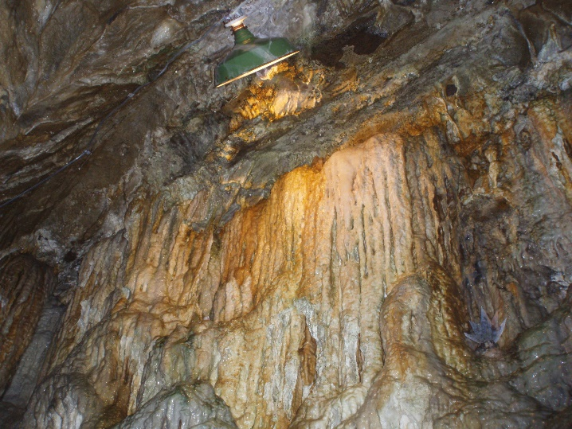
Date: 12/5/2020

Details: We will depart from Hatboro on Saturday (12/5/20) at 8:15 AM. We will be touring the cave at Lost River Caverns. After the cave tour we will return to Hatboro, probably around noon.

About Lost River Caverns: In the late 19th century a limestone quarry operated at what is now Lost River Caverns. Quarry workers first discovered the cave entrance in 1883 when they ignited black powder to remove limestone from the cliff face. Since then the cave has seen activity as a ballroom and fraternity initiation ceremonies, as well as other activities. In 1930 the cave was opened for tours.

Cost: $15.00/scout or scouter. This does not include food. Cash or check to Mr. Marks by November 30th. You can also send your payment directly to Mr.Dutill by venmo at @Brian-Dutill1.

Scouts Name: _________________________ Patrol: ____________________

Scouters Name: _____________________________________

Can you drive? Yes: _____ No: _____ # Seats: _______ Tow? Yes_____ No ___

