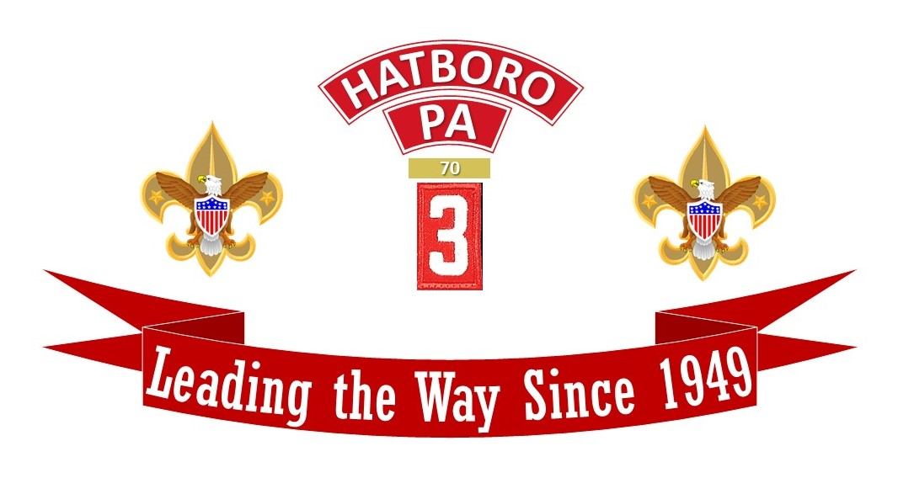

70th ANNIVERSARY

Saturday September 14, 2019

Robert J. Waeltz Daniel M. Marks
Scoutmaster Troop Committee Chair

70 YEARS WITH HATBORO TROOP 3

Seven decades…from 1949 to 2019. Harry Truman was President of the United States and a baseball team named the Athletics played in a place called Shibe Park in the city of Philadelphia. World War II had ended only 4 years prior, and over the next 70 years, 12 men would serve as President of the United States. The Korean conflict was still a year away and the War in Vietnam would not begin for another 15 years. But in a small town called Hatboro Pennsylvania, Troop 3 was chartered to Hatboro Baptist Church.

Troop 3 was the 3rd Troop in Hatboro to be awarded a charter by the Boy Scouts of America, thus the number 3. Troop 3 was chartered in the Valley Forge Council in Washington District. The national number was Troop 446 and would remain that way until the merger of the Valley Forge Council and Philadelphia Council in 1996. Troop 3 never used the number 446, but always identified as Troop 3.

Troop 3’s first Scoutmaster, Len Henryson, was an Eagle Scout...as is the Troop’s longest serving Scoutmaster Bob John. More about him later.

Pride has always been an important word in the 70-year history of Troop 3. Pride, as C. Stoy Weaver wrote in a 25-year history of the troop, has been instilled by its 14 Scoutmasters and the outstanding young men who have worn the troop “3” patch on their shirt sleeves.

A continuing thread of quality that has blessed Troop 3 is its Scoutmaster ranks.

Len Henryson was widely regarded as the spark plug who kept Troop 3 together through a hectic first year…a year highlighted by the Troop winning the Delmont Olympics (a competition that combined scouting and athletic skills) during the Troop’s inaugural stay at summer camp.

Len Henryson was followed as Scoutmaster by Warren Clemens, a Hatboro gun collector; Ellsworth Snyder whose son was a member of the troop and Bill Clausen, the uncle of a troop member. Bill Clausen had been succeeded by Bob Casey, who had been troop Committee Chairman and agreed to take the post on an interim basis so that the troop’s charter could be retained.

The search for Scoutmaster #6 ended, quite surprisingly, when John G. Weand, who for many years was an active scout and scouter in Norristown, came to a committee meeting and announced that he would like to be the troop’s Scoutmaster. The bright and quick-thinking members of the committee were quick to accept the offer.

Under Weand’s direction, the troop experienced excellent growth in membership, activities and good reputation.

There was an interesting irony in Weand’s leaving Troop 3. As a member of Hatboro’s Lehman Methodist Church, he felt a strong sense of responsibility when Lehman Methodist experienced Boy Scout Leadership problems.

Weand was prevailed upon to become the Scoutmaster of Lehman Methodist’s Troop 81 and Troop 3 had the great fortune to have C. Stoy Weaver to take over the Scoutmaster position-if only on a short-term basis.

Weaver, an Assistant Scoutmaster at the time, said he would be Scoutmaster of Troop 3 until a more permanent successor could be found. Stoy Weaver was a legend of scouting in the town of Hatboro as well as a much broader territory. Stoy Weaver, Scoutmaster #7 at Troop 3, served as a committee member on the District staff and could always be found hiking or camping someplace.

Jesse Burnett, a wide-smiling Texan with a fantastic drawl was the next Scoutmaster. Like Stoy Weaver, Jesse was an outstanding camper and was a leader for high-adventure trips to Canada and many other rugged locations.

Work assignments forced Jesse to relinquish the Scoutmaster position and he was succeeded by Hank Hudson who had two son’s become Eagle Scouts.

Scoutmaster #10 was Harry Hilger who also served as the Troop Committee Chairman and Harry was followed by Ralph Nagle who became active in the troop when his oldest son joined.

The longest running term as Scoutmaster belongs to Bob John, who served as Scoutmaster from 1972 until his retirement, 40 years later, in 2012. A Hatboro Troop 3 alum, Bob John earned his Eagle rank in 1962 and is in many ways, “Mr. Hatboro” as well as “Mr. Troop 3”. He is a graduate of Hatboro High School and the Villanova University Law School and currently practices law in Hatboro.

In addition to his leadership role with Troop 3, Bob has an impressive list of accomplishments in scouting, including serving on the staff of the Washington District, Valley Forge Council and Schiff Scout reservation. He was also program director at Camp Comer in Alabama and was instrumental in having Troop 3 visit that facility in the northeast corner of Alabama near Fort Payne for summer camp.

Stuart Gentry would become Scoutmaster #13. Stuart, a chemist and lawyer, was an Assistant Scoutmaster prior to taking the role of Scoutmaster. He is an avid outdoorsman with three children, one of whom was a Senior Patrol Leader and Eagle Scout. Stuart would serve as Scoutmaster from 2012 until 2015 when he and his wife would re-locate to Colorado.
In May of 2015, Bob Waeltz was installed as Scoutmaster #14 and continues to serve in that role. His son is an Eagle Scout and former Senior Patrol Leader. Bob was an Assistant Scoutmaster and ran the New Scout Program prior to becoming Scoutmaster.

Firsts have always been a priority for Troop 3. Tom Casey was the first troop member to attend Philmont Scout Ranch in New Mexico. He attended the ranch in 1955. The first Troop 3 contingent to attend Philmont was comprised of Fred Ewald (chairman of the 25th anniversary celebration), Bob Kay, Don Gleiter, Russ Casey, Neil Farnsworth and Tom Weaver. They were at Philmont in 1949. Tom Casey was also the first Troop 3 scout to attend a National Jamboree, camping with folks from across the nation and around the world in 1957 at Valley Forge.

So, what has been happening since we celebrated our 60th Anniversary ten years ago? Plenty, but that should come as no surprise to anyone.

There is always camping and adventure with Troop 3, even if the weather isn’t always what you see in post cards. Camping and activity locations have Resica Falls, Mt. Norris Scout Reservation, Haliburton, Baiting Hollow, Yawgoog, Camp Buckskin and Goose Pond for summer camps. Other notable trips have included; Harrisburg, Canoeing the Antietam Creek, Allaire State Park, the US Military Academy at West Point, the US Naval Academy, the Grand Canyon of PA, Cape Henlopen and Cooperstown.

Troop 3 has also gone backpacking the Quehanna Trail, whitewater rafting on the Lehigh River and the Youghiogheny River in western Pa, and visited Holtwood Environmental Center, Ricketts Glen and Worlds End State Parks as well as the Rhinebeck Aerodrome, Manassas Battlefield in Virginia and French Creek State Park. The list could go on and on.

High Adventure Trips over the past 10 years are just as impressive. Of course, there are our trips to Philmont. We’ve sent contingents in 2010, 2012, and 2017 and we have a contingent preparing for a 2020 trek. In addition to Philmont, there is the annual High Adventure Trip to Mt. Washington in New Hampshire. Other High Adventure Trips have included canoeing the Allagash Wilderness Waterway in Maine and backpacking the final leg of the Appalachian Trail to Mt. Kathadin in Maine.

And if high adventure, terrific camping and excellent fellowship are not enough to provide fond memories of 70 years of scouting in Troop 3, the caring reputation of the troop is. If a job needs doing and it must be done right, people in the community can always count on Troop 3.

If a good deed was needed, who else but the members of Troop 3 were there to do it? So beyond regular weekly meetings, summer camp and weekend camping trips, there was always the knowledge that the fine young men of the community were becoming better young men and outstanding adults thanks to Troop 3 and its community presence.

And the community was always there to help Troop 3. Since chartering Troop 3, Hatboro Baptist Church has been a tremendous support to the troop. So have been the generous people who have supported our pancake breakfasts and Ham and Turkey Suppers and those who have bought Camp/Adventure Cards. As much as the community was present, so to have been the parents of our scouts. They have served timelessly and enthusiastically as leaders, assistants, committee members, drivers, coordinators, phone contacts, arrangers, dishwashers and cooks. We could not have done any of this without all of you.

So, here is to every one of you. Our scouts, adult staff, committee members, parents, community members, staff and congregation of Hatboro Baptist Church, and to anyone who has ever supported the mission of Hatboro Troop 3,“We thank all of you for your incredible support over the last 70 years.”

Troop 3 – seven decades old and proud. Proud of it’s past and excited for the future. Troop 3 truly has been “Leading the Way since 1949.”

HATBORO TROOP 3
EAGLE SCOUTS

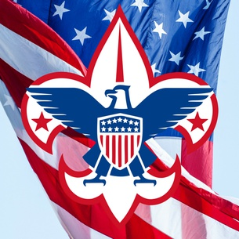
Tom Casey 1957
Bill Kay 1957
Charles Zimmerman 1958
Russell Casey 1959
Robert Kay 1960
Dick Gerhart, Jr. 1961
Robert John 1962
Frank Meily 1963
Donald P. Gleiter 1963
Robert Hudson 1965
Thomas Peterson 1966
David Kutz 1967
Robert Trent 1968
Thomas Hudson 1969
Richard Fuller 1969
Tom Morrow 1970
Richard A. Wagner 1970
Steven Chant 1972
Steven M. Hammonds 1974
Glen Nagel 1974
Gregory A. Sulat 1977
James W. Rinier 1979
Robert C. Ewald 1979
Jeffrey C. Spicer 1979
Rudolf G. Tellmann, Jr 1979
Jeffrey A. Kiel 1980
Kyle H. Jones 1982
Stephen E. Kiel 1983
Stephen R. Maund 1983
Timothy Stauffer 1984
Stuart W. Luce 1984
Jeffrey L. Burnley 1985
Mark Maund 1985
Eric Baranowski 1986
Daren A. Hall 1988
Richard Todd Lewis 1988
Jeff Maund 1989
Norman Miles 1989
Charles Lutz 1989
Tim Fortunato 1989
Michael Fortunato 1990
E.P. Bock 1990
Keith McCrary 1990
Greg Robinson 1990
Gregory Bock 1991
Kevin Fortunato 1991
Todd Cooper 1991
Nick Dautel 1992
Jon Meade 1992
T.J. Shurtz 1995
David J. Bernard 1995
Christopher Gilman 1996
John Green 1996
Peter J. Gramp 1996
Jonathan Pollock 1997
James A. Blowinski 1997
Russell Neumann 1997
Ryan M. John 1997
Jordan L. Broady 1998
Eric M. Wagner 1998
Chris Ryan 1998
Michael Thornburg 1999
Dan Murphy IV 1999
Michael Applegate 1999
Matthew E. Rose 1999
Daniel S. Haddon 2000
Bryan C. Gilson 2000
Joseph V. Plakis, III 2000
Andrew M. Wilkowski 2000
Michael B. Murphy 2000
Anthony M. McCulla 2000
Mark Matthews 2001
David Meinhardt 2001
Timothy Ryan 2001
Drew Novelli 2001
Andrew Gilman 2001
Sean O. Kelley 2001
David Matthews 2002
Andrew Matthews 2002
Christopher F. Burrell 2002
Craig W. Versek 2002
Douglas S. Pfeil 2002
James S. Topper 2002
Alex A. Field 2003
Timothy E. Britt 2004
Colin P. Kelley 2004
Brett Fisher IV 2004
Brendan Connolly 2004
Andrew Meinhart 2005
Matthew Merenda 2005
Matthew Field 2005
Bruce McCaffrey, Jr. 2005
Timothy L. Plunkett 2006
Michael D. Sams 2006
John P. Sheppleman 2006
Michael Layton 2006
Scott S. Cunningham 2006
Joseph A. Tustin 2007
Daniel A. Field 2007
Joseph Allard, II 2007
Kyle A. Glensky 2007
Kyle R. Hallowell 2007
William J. Austin 2007
Daniel J. Thompson 2007
Andrew J. Garrison 2007
Dean W. Russell 2007
Andrew K. Pfeil 2007
George C. Fesmire 2007
Dan Plunkett 2008
Michael L. Wilks 2008
Shawn Allard 2008
Matthew J. Jevit 2008
Eric Gentry 2008
Bryan Cross 2009
Brendan B. Fisher 2009
Jeffrey W. Thompson 2009
Justin Sitasz 2009
William R. Walls 2009
Andrew J. Yale 2009
Patrick Cero 2009
Robert J. Waeltz, Jr. 2010
Bryan Graf 2010
Kurt Rosenberger 2012
Joseph Moore 2012
Ethan McCulla 2013
Matthew Sheridan 2013
Dylan Brown 2013
Michael Balot, II 2013
Stephen Tritsch 2013
Jeffrey Dieterly 2013
Christopher Atras 2013
Dylan A. Callum 2013
Jason R. Graf 2013
Matthew Rabii 2014
Colin Jacob Fisher 2014
Kurt Herbine 2014
Taylor Lauer 2014
Nickolas Kelly 2015
Brandon Gomez 2015
James V. Iaia 2015
Nathaniel K. Ehly 2015
George Balot 2015
Angel L. Gauthier, Jr 2015
Jacob Pilch 2015
Richard Schoellhammer 2015
Corey D. Brown 2015
Kyler K. Grimes 2016
Ryan L. Walsh 2016
Jospeh M. Dutill 2017
Michael Jaeschke 2017
Dawson Stremme 2017
Sean Delaney 2017
David McCann 2017
Daniel McKay 2018
Carter Miller 2018
Ryan C. Smith 2018
Christopher Carenzo 2019
Benjamin Iaia 2019

TROOP 3 SCOUTMASTERS

L.E. “Len” Henryson 1949-1950
Warren Clemens 1950-1951
Ellsworth Snyder 1951-1953
William Clawson 1954-1955
Robert Casey 1955-1956
John Weand 1956-1961
1970-1971
C. Stoy Weaver 1961-1962
Jesse Burnett 1963-1966
Henry “Hank” Hudson 1966-1968
Harry Hilger 1969-1970
Ralph Nagle 1970-1972
Robert John 1972-2012
Stuart Gentry 2012-2015
Robert Waeltz 2015-Present

FOUNDING LEADERS OF TROOP 3

L.E. Henryson Scoutmaster
Joseph Carter Asst. Scoutmaster
John Sugars Asst. Scoutmaster
William Ritchie Asst. Scoutmaster
Robert Casey Committee Chair
Frank Orce Charter Org. Rep.
Willis Welsel Committee Member

SENIOR PATROL LEADERS

Neil Gutekunst 1972-1973
Steve Hammonds 1973-1974
Glen Nagle 1974-1975
Arnie Berkowitz 1975-1976
Jim Rinier 1976-1977
Rudy Tellmann 1977
John Tiley 1977-1978
Bob Ewald 1978-1979
Jeff Kiel 1979-1980
Steve Kiel 1980-1981
Steve Maund 1981-1982
Stuart Luce 1982-1983
Jeff Burnley 1983-1984
Tim Stauffer 1984-1985
Todd Lewis 1985-1986
Eric Baranowski 1986-1987
Tim Fortunato 1987-1988
Charles Lutz/
Jeff Maund 1988-1989
Greg Robinson 1989-1990
Mike Fortunato 1990-1991
E.P. Bock 1991-1992
Norman Miles 1992-1993
Kevin Parker 1993-1994
Greg Bock 1994-1995
Peter Gramp 1995-1996
Chris Ryan 1996-1997
Jordan Brody 1997-1998
Dan Haddon 1998-1999
Matt Fisher 1999-2000
Andrew Gilman 2000-2001
Colin Kelley 2001-2002
Mike Sams 2002-2003
Chris Burrell 2003-2004
Carl Blum 2004-2005
George Fesmire 2005-2006
Keith Sansoni/
Jeff Thompson 2006-2007
Kyle Hallowell 2007-2009
Matt Jevit/
Eric Gentry 2009-2010
Robert Waeltz, Jr. 2010-2011
Chris Atras 2011-2012
Joseph Moore/
Nick Kelley 2012-2013
Jason Graf/
Nick Kelley 2013-2014
Patrick Lavelle/
George Balot 2014-2015
Ryan Walsh/
Kyler Grimes 2015-2016
Dawson Stremme 2016-2017
Daniel McKay 2017-2018
Daniel Lee/
Nathan Kephart 2018-2019
Manas Date/
Nathan Kephart 2019-2020

UNIT LEADER AWARD OF MERIT

Stuart Gentry 2015
Robert Waeltz 2017

ST. GEORGE AWARD

David W. Cooper
TROOP 3 SILVER BEAVER
RECIPIENTS

Fred G. Ewald
Richard Gerhardt
William Kay
Morris McFarland
C. Stoy Weaver
Robert M. John
Stan Berkowitz
John G. Weand
David W. Cooper
William Kuhfuss
Peter Walts
Michael Bernard
Rudolf G. Tellmann

NATIONAL COUNCIL SERVICE
AWARD

Robert M. John
JAMES E. WEST FELLOWSHIP

Robert M. John
Kyle Hallowell
Georgi Bernard
Michael Bernard
Peter Walts
David W. Cooper
Barry Fisher
Lester Blum
Scott Herbine
Rudy Tellmann

NATIONAL MEDAL OF MERIT

Doug Pfeil
Ed Cordenner

SILVER ANTELOPE AWARD

David W. Cooper

WOOD BADGE RECIPIENTS

Richard Gerhardt
Robert M. John
Gary Luce
Douglas Gramp
David Cooper
Georgi Bernard
Michael Bernard
George Fesmire
Larry Wilks
Lester Blum
Kris Field
Robert Genn
William Kuhfuss
Peter Walts
Todd Cooper
Michael Balot
Craig Lauer
Stuart Gentry
Keith Grimes
Brian Dutill

TROOP 3 AWARD OF MERIT RECIPIENTS – WASHINGTON DIST.
Frank W. Kay 1958
Fred G. Ewald 1960
Richard Gerhardt 1965
C. Stoy Weaver 1966
John G. Weand 1968
Stan Berkowitz 1977
Robert M. John 1978
Charles Spicer 1980
J. Allen Kiel 1982
Ray Luce 1986
Ray Maund 1987
David Cooper 1988
Doug Gramp 1994
Tim Thornburg 2001
Ed Wilkowski 2002
Daniel Murphy 2003
William Kuhfuss 2004
Steve Gilman 2005
Michael Bernard 2006
Kris Field 2007
Barry Fisher 2008
Lester Blum 2010
Craig Louer 2012
Rudy Tellman 2016

In Memoriam

Sadly, we have lost the following Scouters since our 60th anniversary. Troop 3 wishes to thank these men for their service and dedication to the troop and also their families for sharing them with us. As Scouters, we can only hope that we can serve and represent the ideal scout as well as these men did in their lifetime.

Doug Gramp
Ed Wilkowski
Owen Adams
Bill Walls
Rudy Tellman

