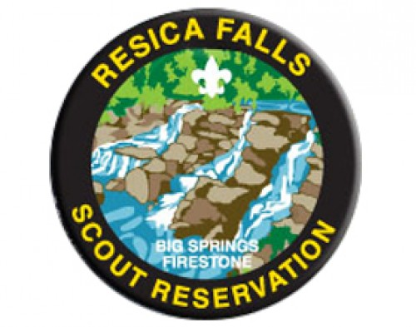
Resica Falls – Firestone Lodge Trip
February 15-17, 2019

Join us on this awesome trip to Resica Falls; we will be staying in the beautiful Firestone Lodge!
(If you are getting ready for Mt. Washington – you’ll camp outside!)
Events include: Hiking, Shooting - Rifle, Shotgun and Pistol
Skiing (there is an extra cost – see separate flyer – 15 person minimum)
$30 per person
Includes travel expenses and all food
All money is due by 2/4

Questions – contact Rob Walsh: walsh5@comcast.net or 267-872-6770
---------------------------------------------- cut here, return bottom portion with check -------------------------------------------
Scout’s Name: ________________________ Patrol: _____________________
Scouter’s Name: ______________________ Email Address: ________________
Number attending: ______ X $30.00 each Total: $____________
Make Checks payable to Hatboro Troop 3

Can you Drive? Yes No Can you Tow? Yes No
Number of seats with seatbelts in the vehicle (including driver): __________

