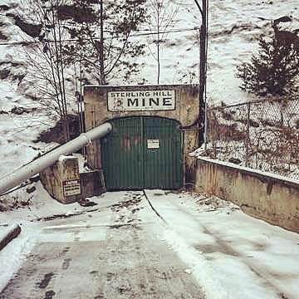
Sterling Hill Mining Museum
January 18th – January 20th
Cost: $40
Cabin Camping. No tents needed!
Troop Feed
Come out and see the Sterling Hill Mining Museum. This weekend trip will consist of a 2 hour guided walking tour of the Sterling Hill Mine. We will see what mining operations were like in the 1830’s and find out why this area is known as the “Fluorescent Mineral Capital of the World”.
After the tour there is an opportunity to do your own fluorescent mineral collecting in the Mine Run Dump* (additional cost applies)
Optional Mineral Collecting:
$5.00 Admission for mineral collecting area
$2.00 per lb of rock taken
Must bring your own hammer
Must wear closed-toe shoes
A new pay option is available. Pay with Just download the app and setup an account. Send payments to the troop treasurer Brian Dutill @ Brian-Dutill-1

Contact Jared Snyder (Snyder.Jared@gmail.com) or
Chris Marks (christophermarks2@gmail.com) with questions.

Scout(s)
Scouter
Able to Drive |  | Number of seatbelts
Mineral Collecting?

